Dog Breed Classification
Preprocessing Documentation

1. Project Overview
Objective: Extract deep learning features from dog images using pre-trained ResNet50 for classifying 5 dog breeds: Golden Retriever, Pug, Beagle, German Shepherd, and Chihuahua.
2. Data Organization
The dataset was organized by selecting 5 dog breeds from the ImageNet dataset. Images were copied from folders with synset IDs (e.g., n02099601-Golden_retriever) to simplified breed-named folders (e.g., golden_retriever) in the data/selected_5_classes directory.
3. Image Loading
loads images from organized folders, converts them to RGB format, and assigns integer labels (0-4) to each class. It handles corrupted images gracefully and returns PIL images with their corresponding labels and class mappings.
4. Image Preprocessing
standardizes images for ResNet50 input:
- Resize: All images to 224×224 pixels
- Normalization: Applied ImageNet mean [0.485, 0.456, 0.406] and std [0.229, 0.224, 0.225]
- Output: Normalized tensors of shape [3, 224, 224]
5. Feature Extraction
5.1 Model Configuration
Used pre-trained ResNet50 with the final fully-connected layer removed to extract 2048-dimensional feature vectors instead of class predictions.
5.2 Extraction Pipeline
processes images in batches of 32 using a custom PyTorch Dataset and DataLoader. Features are extracted via forward passes through the model in evaluation mode (no gradients). The output features are flattened and saved as NumPy arrays.
6. Data Splitting
divides the extracted features into training (70%), validation (15%), and test (15%) sets using stratified sampling to maintain class distribution. All splits are saved as separate NumPy files in the data/features directory.
7. Output Files
- X_features.npy: Feature vectors (shape: [n_samples, 2048])
- y_labels.npy: Integer labels (shape: [n_samples])
- X_train.npy, X_val.npy, X_test.npy: Split feature sets
- y_train.npy, y_val.npy, y_test.npy: Split labels
- class_names.json: Class name to integer mapping

8. K-Means Clustering
8.1 Objective
The objective of this stage is to apply unsupervised learning using the K-Means clustering algorithm on the deep features extracted from images to group samples into clusters corresponding to the five dog breed classes.
Although K-Means is an unsupervised algorithm, clustering results are evaluated against the true labels to assess how well the extracted features separate the classes.

8.2 Input Data
The K-Means model uses the deep feature vectors generated during the preprocessing stage:
Feature vectors extracted using ResNet50
Feature dimensionality: 2048
Data loaded from NumPy files:
X_train.npy, X_val.npy, X_test.npy
y_train.npy, y_val.npy, y_test.npy
Class label mappings loaded from class_names.json
All feature splits are concatenated into a single dataset before clustering.

8.3 Data Preparation
Training, validation, and test feature sets are combined to improve clustering stability:
Feature matrix shape:
[number of samples, 2048]
Corresponding ground-truth labels are also concatenated for evaluation purposes only
K-Means itself does not use labels during training.

8.4 Model Configuration
The K-Means algorithm is initialized with the following parameters:
Number of clusters: 5 (equal to number of dog breeds)
Initialization method: k-means++
Number of initializations: 10
Random state: 42 (for reproducibility)
This configuration helps reduce sensitivity to centroid initialization and improves convergence quality.

8.5 Clustering Process
The K-Means model assigns each sample to the nearest centroid
Each sample receives a cluster ID (0–4)
These cluster IDs are arbitrary and do not directly correspond to class labels

8.6 Cluster-to-Class Mapping
To evaluate clustering performance, each cluster is mapped to a class label using majority voting:
For each cluster, the true labels of samples inside the cluster are collected
The most frequent label (mode) is selected
The cluster ID is replaced with the corresponding class label
This step converts unsupervised clustering results into class predictions.

8.7 Evaluation Metrics
After mapping clusters to class labels, performance is evaluated using:
Accuracy
Confusion Matrix
These metrics provide insight into how well the extracted features separate different dog breeds.

8.8 Results and Observations
The clustering performance demonstrates that deep features extracted by ResNet50 are discriminative
Some breed confusion may occur due to visual similarity between certain classes
K-Means performs reasonably well despite being unsupervised
K-Means Clustering Accuracy: 0.9882214369846879

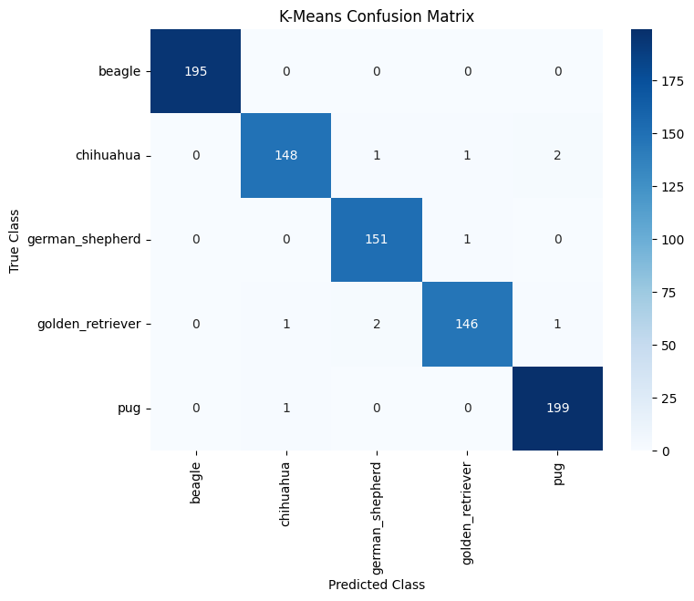

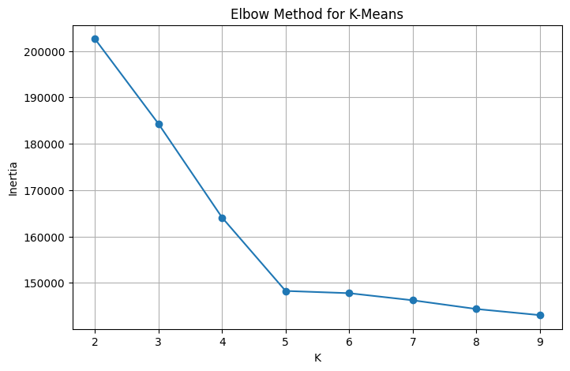9. Logistic regression
9.1 Objective
The objective of this stage is to apply supervised learning using the logistic regression algorithm on the deep features extracted from images to classify samples into one of the five dog breed classes.
The model is trained using the true class labels, and its performance is evaluated using standard classification metrics to assess how effectively the extracted features distinguish between the different dog breeds.

9.2 Input Data
The Logistic Regression model uses the deep feature vectors generated during the preprocessing stage:
Feature vectors extracted using ResNet50
Feature dimensionality: 2048
Data loaded from NumPy files:
X_train.npy, X_val.npy, X_test.npy
y_train.npy, y_val.npy, y_test.npy
Class label mappings loaded from class_names.json
All feature splits are used with their corresponding labels for supervised classification.

9.3 Data Preparation
Since Logistic Regression is a supervised classification algorithm, labeled data is used directly during training:
- Input feature matrix shape:
numberofsamples,2048number of samples, 2048numberofsamples,2048
- Corresponding ground-truth labels represent the five dog breed classes
- The training set is used to fit the model
- The validation set is used for model tuning (if applicable)
- The test set is reserved for final performance evaluation
No concatenation of splits is performed to avoid data leakage and ensure fair evaluation.

9.4 Model Configuration
The Logistic Regression classifier is configured with the following parameters:
- Multi-class strategy: One-vs-Rest (OvR) or Softmax (multinomial)
- Maximum number of iterations: 1000
- Class wight : balanced
- Random state: 42 (for reproducibility)
This configuration enables stable convergence and effective learning from high-dimensional deep features.

9.5 Classification Process
The Logistic Regression model learns a decision boundary for each dog breed class based on the extracted features:
- Model parameters are optimized using labeled training data
- For each input sample, the model computes class probabilities
- The class with the highest predicted probability is selected as the final prediction
Each sample is directly assigned a predicted dog breed label.

9.6 Evaluation Metrics
The performance of the Logistic Regression classifier is evaluated using supervised classification metrics on the test dataset.
- Accuracy
The model achieved an overall accuracy of 99.22%, indicating excellent classification performance across the five dog breed classes.
- Classification Report
Precision, recall, and F1-score are computed for each class to provide a detailed evaluation:
  - Beagle: Perfect precision, recall, and F1-score, indicating flawless classification.
  - Chihuahua: High performance with a slight reduction in precision, suggesting minimal confusion with other classes.
  - German Shepherd and Golden Retriever: Perfect scores across all metrics, reflecting strong feature separability.
  - Pug: High precision and recall with a minor decrease in recall, indicating very few misclassifications.
- Macro and Weighted Averages
Both macro and weighted averages achieved values of 0.99 for precision, recall, and F1-score, confirming consistent performance across all classes regardless of class distribution.
These results demonstrate that the deep features extracted using ResNet50 are highly discriminative, enabling Logistic Regression to effectively classify the five dog breed classes.

